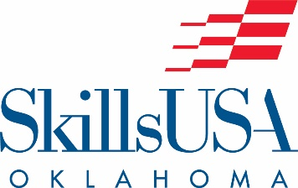

Related Technical Math
State Contest Information

Date, Time and Location of Contestant Meeting

The 2024 State SkillsUSA Related Technical Math Contest will be held in-person on Monday, April 22 at Cox Convention Center, Tulsa, Oklahoma. Contestants must report to the Contest Chair at the contest area in the Tulsa Ballroom at 8am.

Clothing Requirements
Contestants MUST wear official SkillsUSA dress attire for contest. A clothing penalty will apply for any deviations from official dress. Class E: Competition Specific — Business Casual allowed.

Equipment and Materials
1. Supplied by the technical committee:
a. Test problems and instructions
b. Scratch paper
c. Formula sheets and conversation tables/charts

2. Supplied by the competitor:
a. Hand-held calculator
b. No. 2 pencil
.
Contestant Resume
All contestants will be required to submit a one page, typed resume. If any contestant does not submit a resume to the contest chair, penalty points will be assessed.

Rules and Regulations
SkillsUSA (PDP) test will be taken on-line March 13-April 9. Students need to coordinate with testing centers on their campuses to complete testing.
Students have two hours to complete the problems and check their answers.
Official outline of contest for Related Technical Math, found/accessed through Absorb. Please read over technical carefully.
Awards Ceremony
Contest winners will be recognized at the General Session on Tuesday morning, April 23rd, at 9a.m. in the Tulsa Convention Center Grand Hall. Contest winners will not be allowed on stage if not in official dress.

For men: Official blazer, jacket or sweater; black dress slacks; white dress shirt; plain black tie with no pattern or SkillsUSA black tie; black socks and black shoes.
For women: Official blazer, jacket or sweater; black dress slacks or knee-length skirt with businesslike white, collarless blouse or white blouse with small, plain collar that may not extend onto the lapels of the blazer, and black dress shoes.

