Laundry Sorting and Folding – Revised 8/19/2019
Laundry sorting and folding, an individual event*, allows the participant to demonstrate the ability to sort and fold towels in a specific amount of time.
ELIGIBILITY
- A chapter may submit three secondary and three post-secondary entries in this event.
- Open to active SkillsUSA members enrolled in career and technical programs with entry-level job skills as the occupational objective. A letter from the appropriate school official on school letterhead stating that the contestant is classified under the provisions of Public Law 105-17, Individuals with Disabilities Education Act, 1997 is required for participation. State/school associations having restrictions on the release of this information may submit a letter on school letterhead of eligibility which simply states: ‘I certify that (student name) meets the eligibility requirements for the SkillsUSA Championships Laundry Sorting and Folding contest. Signed (school official).” The eligibility letter is to be presented to the contest chair at the contest orientation meeting.
- Each participant must submit a personal resume during sign-in.
CRITERIA FOR EVALUATION
Participants will be evaluated on their ability to:
- Remove all items from basket
- Remove basket from the work station
- Separate bath towels, hand towels and wash clothes as they are removed from the basket
- Fold towels and wash clothes neatly with corners matching and few or no wrinkles
- Stack folded towels and wash clothes together, largest items on the bottom
- Complete tasks in allowed time
- Signal timekeeper when finished

PROCEDURES AND TIME REQUIREMENTS
- Participants must attend the event orientation session where they will:
- Receive a nametag and contestant number
- Be given an overview of the event and the participant’s responsibilities
- Participants will remain in the holding area until the assigned time.
- The following equipment/supplies will be furnished:
- Table or other folding surface
- Laundry basket
- Articles in the basket (will include two bath towels, two hand towels and two wash clothes)
- Each participant will have 10 minutes to:
- Remove all items from basket
- Remove basket from the work station
- Separate bath towels, hand towels and wash clothes as they are removed from the basket
- Fold towels and wash clothes (see examples on next page)
- Stack folded towels and wash clothes neatly
- Place largest items at bottom of stack
- Leave stack on table (see example on next page)
- The maximum time allowed will be 10 minutes.
- Times will be used as a tiebreaker.
- Participants will be stopped at the end of 10 minutes.
- All judges’ decisions are final.
*Students who communicate through an interpreter may use their interpreter during the skills demonstration. Students who require reading assistance may request to have any written tests read to them.
Laundry Sorting and Folding Information Sheet
Bath Towels

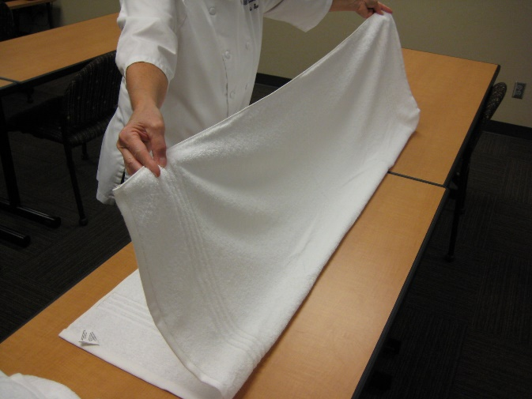  Lay the towel face down on the table (the tag should be facing up). Fold the towel in half lengthwise as pictured above. Note the location of the tag. | 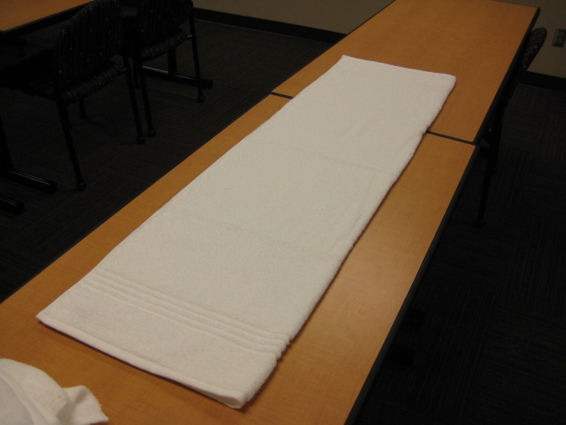  Be sure to line up the corners.
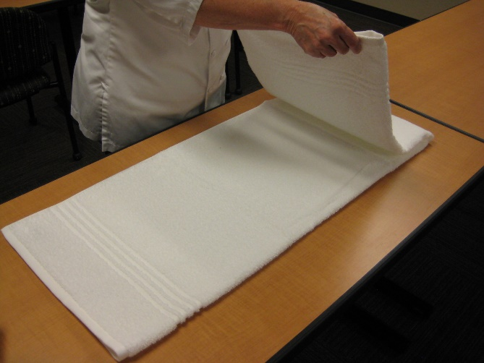  Fold the towel in half crosswise. | 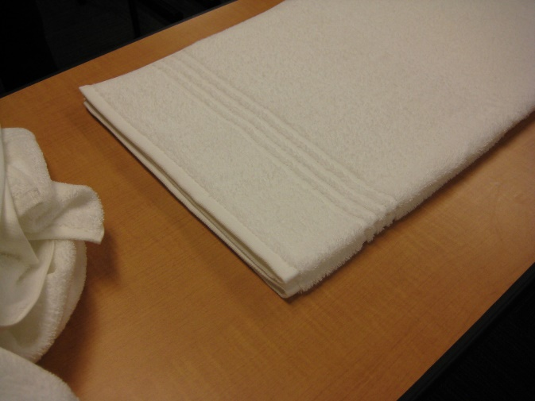  Make sure your corners match.

Laundry Sorting and Folding Information Sheet Cont.

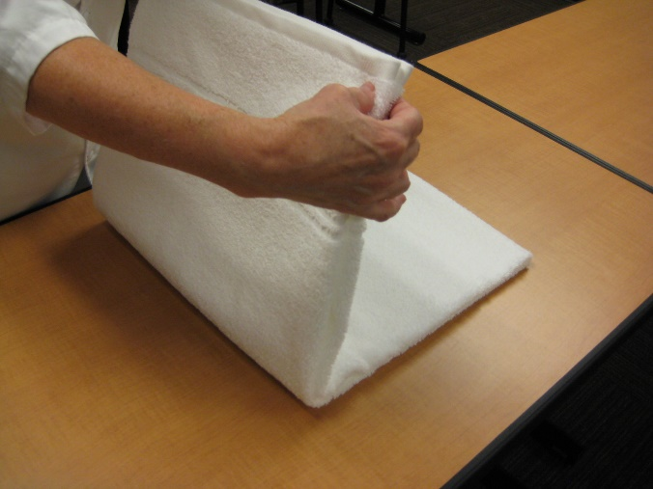  Fold the towel in half crosswise one more time. | 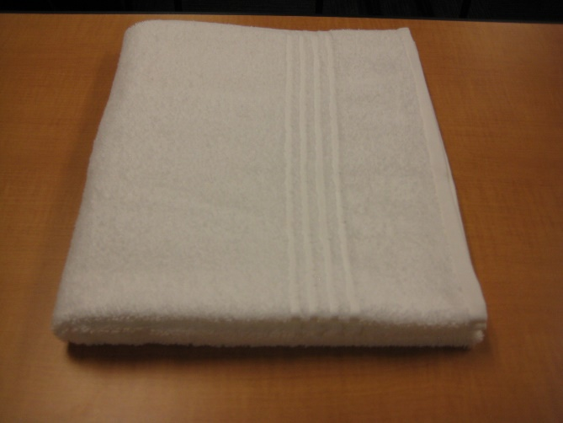  Your folded bath towel should look like this.
Hand Towels

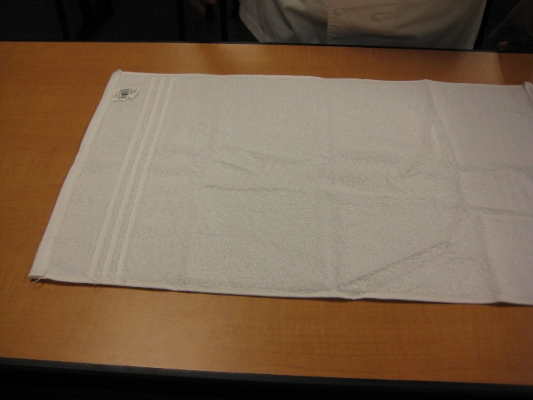  Lay the towel face down on the table (the tag should be facing up). | 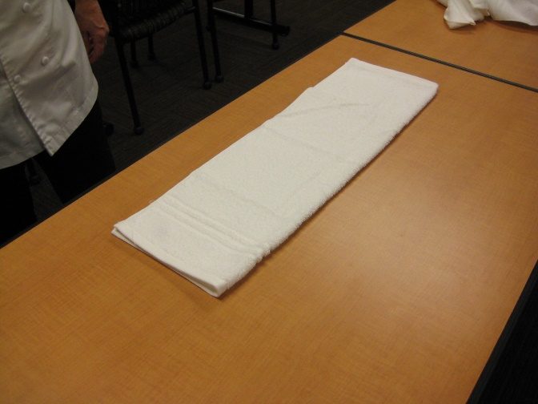  Fold the towel in half lengthwise as pictured above. Be sure to line up the corners.

Laundry Sorting and Folding Information Sheet Cont.

Hand Towels Cont.

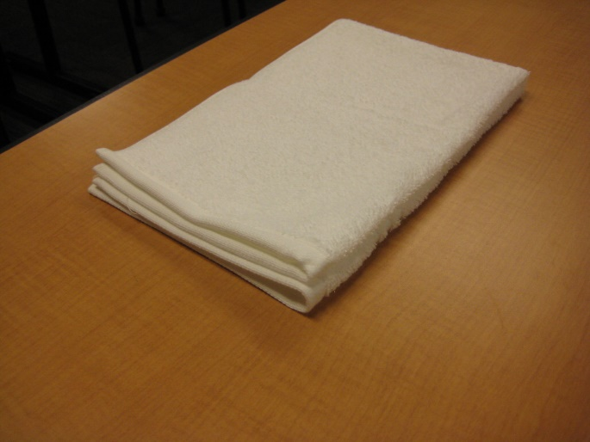  Fold the towel in half crosswise. Make sure your corners match. | Fold the towel in half crosswise one more time.
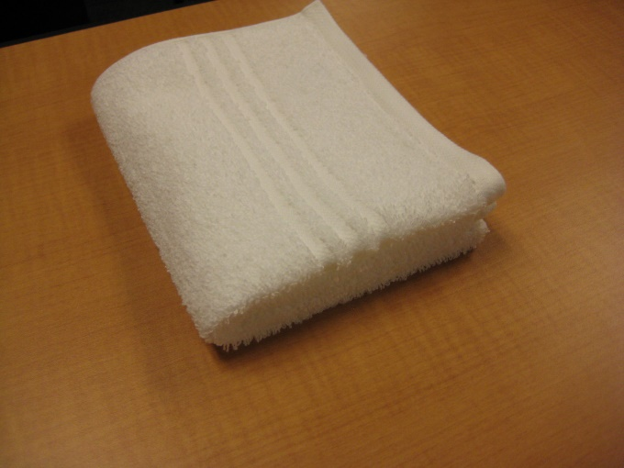
Your folded hand towel should look like this.

Laundry Sorting and Folding Information Sheet Cont.

Wash Cloths

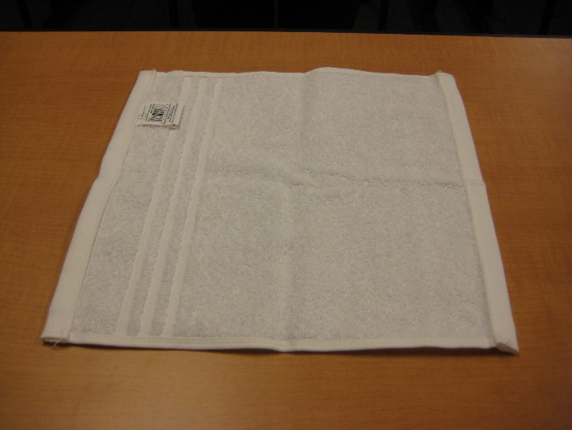  Lay the wash cloth face down on the table (the tag should be facing up). | 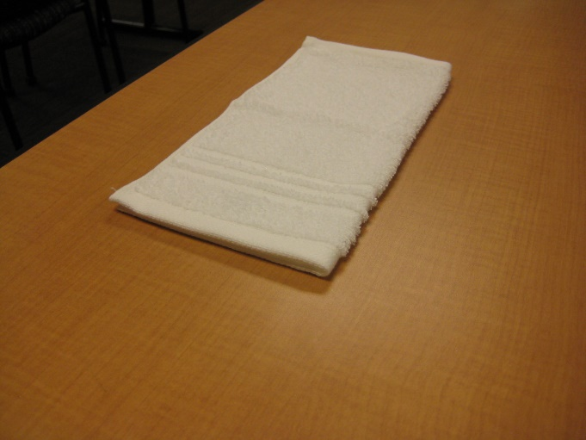  Fold the wash cloth in half lengthwise as pictured above. Be sure to line up the corners.
Fold the wash cloth in half crosswise. Make sure your corners match. | 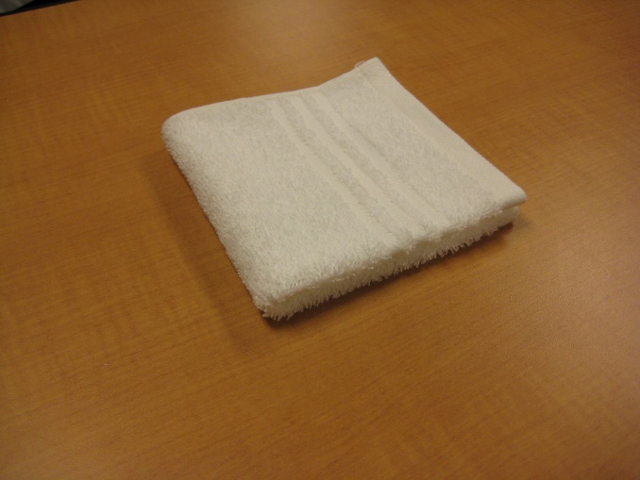  Your folded wash cloth should look like this.

Laundry Sorting and Folding Information Sheet Cont.

Correct Stacking

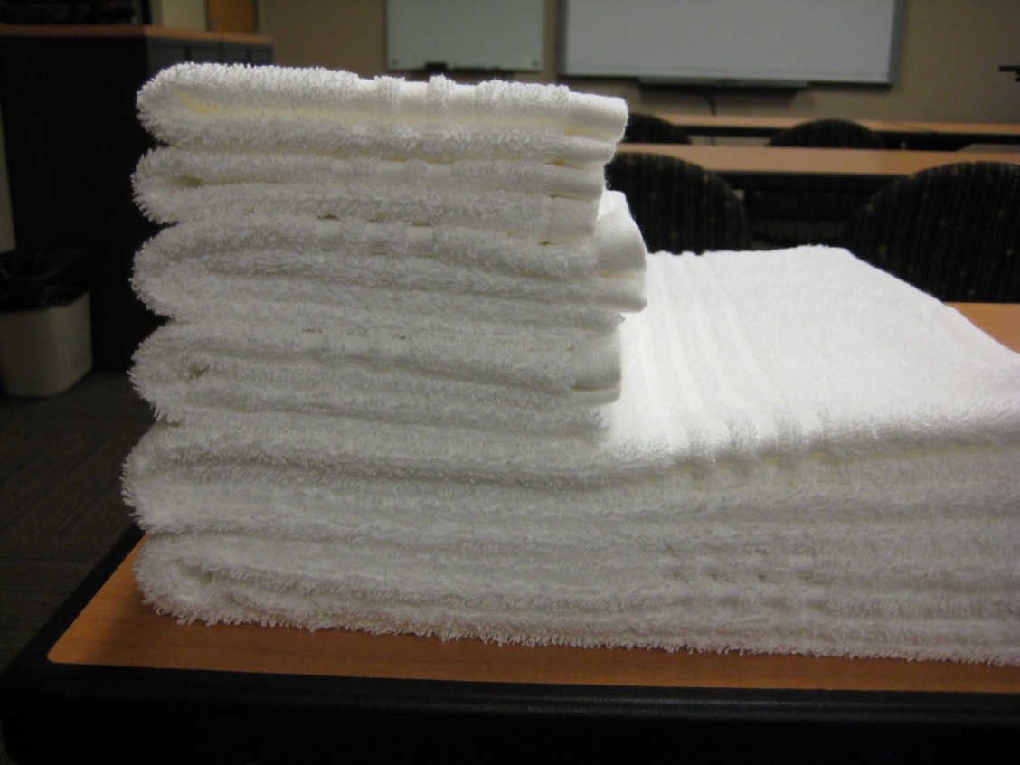
2 bath towels
2 hand towels
2 wash cloths

LAUNDRY SORTING AND FOLDING RATING SHEET

Participant Number: _______________

Instructions: Write the appropriate rating in the “score” column. Add comments to help participants identify their strengths and areas where improvements are needed. Record total points. Verify point total and initial.
Evaluation Criteria | Poor | Fair | Good | Very Good | Excellent | Score | Comments
Separate towels and wash clothes to be folded as they are removed from the basket | 1-2 | 3-4 | 5-6 | 7-8 | 9-10
Remove basket from work surface | 1-2 | 3-4 | 5-6 | 7-8 | 9-10
When folding: towels and wash clothes folded lengthwise, then folded crosswise | 1-2 | 3-4 | 5-6 | 7-8 | 9-10
Match corners on towels and wash clothes | 1-2 | 3-4 | 5-6 | 7-8 | 9-10
Stack folded towels and washcloths together | 1-2 | 3-4 | 5-6 | 7-8 | 9-10
Largest items on bottom of stack | 1-2 | 3-4 | 5-6 | 7-8 | 9-10
Complete tasks in allowed time | 1-2 | 3-4 | 5-6 | 7-8 | 9-10
Signal timekeeper when finished | 1-2 | 3-4 | 5-6 | 7-8 | 9-10
Time: _____________ |  |  |  |  | Total

Judge’s initials: ___________
Contest Chairperson’s initials: ___________

